| **Índice** | **Feature** | **Feature_importance** |
| --- | --- | --- |
| **22** | **PlayType_Field Goal** | **0.00938617903739214** |
| **24** | **PlayType_Kickoff Not Returned** | **0.006724376231431961** |
| **12** | **RosterPosition_Wide Receiver** | **0.005791702773422003** |
| **54** | **PositionGroup_LB** | **0.005278337746858597** |
| **6** | **RosterPosition_Linebacker** | **0.0004196459776721895** |
| **10** | **RosterPosition_Safety** | **0.0** |
| **55** | **PositionGroup_Missing Data** | **0.0** |
| **57** | **PositionGroup_QB** | **0.0** |
| **52** | **Position_WR** | **0.0** |
| **47** | **Position_RB** | **0.0** |
| **51** | **Position_TE** | **0.0** |
| **58** | **PositionGroup_RB** | **0.0** |
| **59** | **PositionGroup_SPEC** | **0.0** |
| **60** | **PositionGroup_TE** | **0.0** |
| **48** | **Position_S** | **0.0** |
| **38** | **Position_ILB** | **0.0** |
| **46** | **Position_QB** | **0.0** |
| **45** | **Position_P** | **0.0** |
| **43** | **Position_NT** | **0.0** |
| **42** | **Position_Missing Data** | **0.0** |
| **40** | **Position_LB** | **0.0** |
| **39** | **Position_K** | **0.0** |
| **37** | **Position_HB** | **0.0** |
| **5** | **RosterPosition_Kicker** | **0.0** |
| **33** | **Position_DE** | **0.0** |
| **32** | **Position_DB** | **0.0** |
| **28** | **PlayType_Punt Not Returned** | **0.0** |
| **25** | **PlayType_Kickoff Returned** | **0.0** |
| **20** | **Weather_Snow** | **0.0** |
| **61** | **PositionGroup_WR** | **0.0** |
| **?** | **Position_FS** | **0.0** |

Todas as features que foram retiradas com base no critério “Feature_importance <0.01”

Modelo 1:

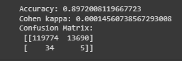

Modelo 2:

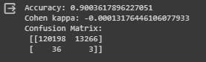

Modelo 1:

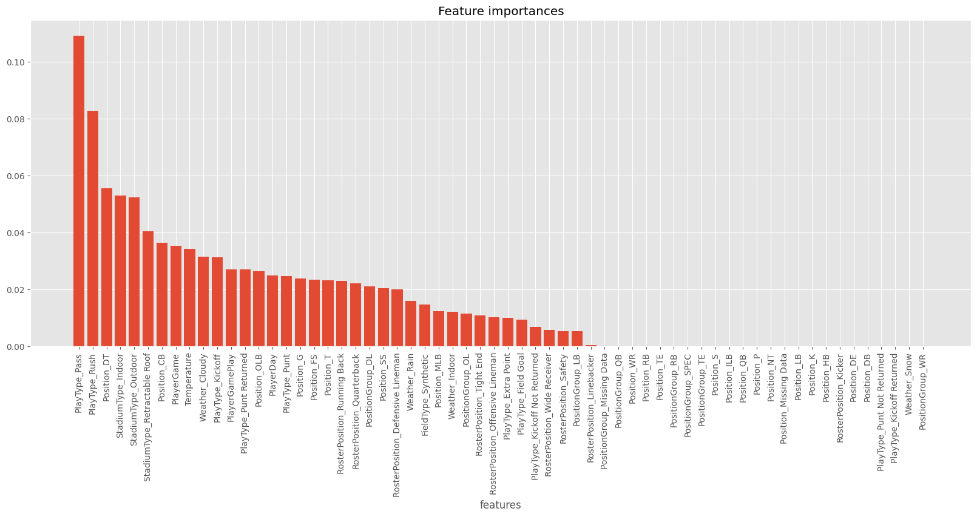

Modelo 2:

